## Example of Line Graph Conversion

Fig. 1 illustrates an example of this transformation: the original graph contains five vertices and six edges, so the corresponding line graph consists of six nodes. For instance, in the line graph, node(corresponding to edgein the original graph) is connected to node(corresponding to edge), because they share vertexin the original graph. It can also be observed that the transformation process has linear time complexity.

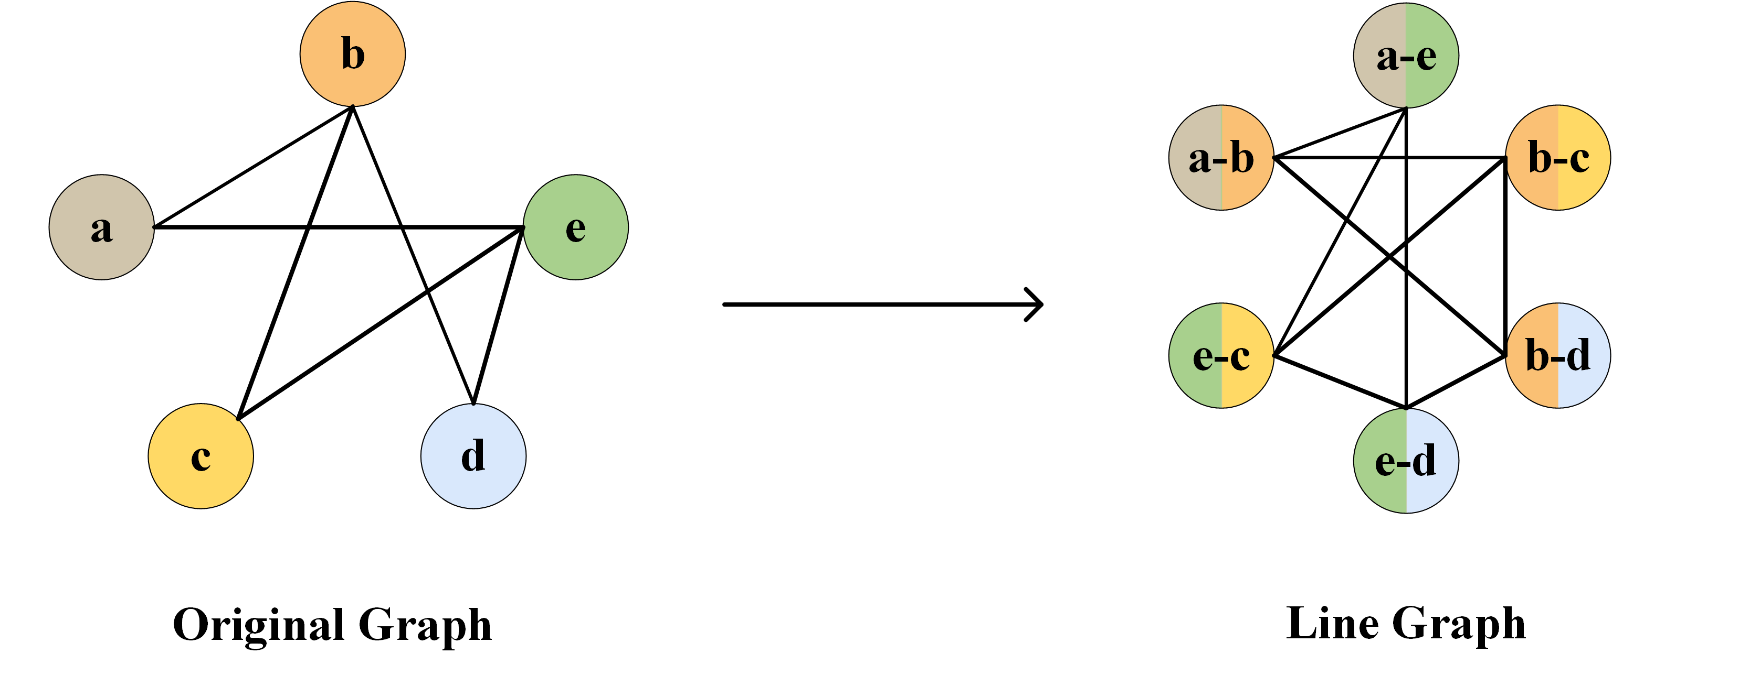

1. Line graph construction schematic diagram. Each node in the line graph corresponds to a unique edge in the original graph and is annotated with its two endpoints

## Data processing

First, we remove genes expressed in less than 10% of cells and genes with low expression levels to filter out low-quality or sparsely expressed features. Next, we apply a log-transformation to the expression matrix of the remaining genes for normalization and calculate the variance of each gene's expression along with its corresponding significance p-value. We specifically retain highly variable genes with Bonferroni-corrected p-values below 0.01 and select the top 500 and top 1000 most variable genes(TFs+500 and TFs+1000) for downstream GRNs inference analysis.

For the STRING, Non-Specific, and LOF/GOF ground-truth networks, we use two-thirds of the known positive samples as the training set and the remaining one-third as the test set. Since the number of negative samples in these three ground-truth networks is significantly larger than that of positive samples, we adopt a uniform random negative sampling strategy. Specifically, for each TF–Target positive gene pair, we randomly assign a negative gene pair with the same TF. In the specific ground-truth networks, we still use two-thirds of the known positive samples for training and the remaining one-third for testing. However, the number of positive samples increases significantly, and as shown in TABLE S1, each TF has a relatively high degree. The imbalance between positive and negative samples is not as severe as in the other three ground-truth networks, so we proportionally split both positive and negative target genes of each TF into the training and test sets. After that, for all networks, we randomly select 10% of the gene pairs from the training set to form the validation set. We use two widely recognized performance metrics: the area under the receiver operating characteristic curve (AUROC) and the area under the precision-recall curve (AUPRC).

Table S1. DETAILED STATISTICS OF THE DATASETS(AVG IS THE AVERAGE NUMBER OF EDGES PER TF)

|  |  |  |  |  |  |  |  |  |  |
| --- | --- | --- | --- | --- | --- | --- | --- | --- | --- |
| **Cell types** | **Cells** | **STRING** | | | | **Non-Specific** | | | |
| **TFs** | **Genes** | **Edge** | **AVG** | **TFs** | **Genes** | **Edge** | **AVG** |
| **hESC** | 758 | 343(351) | 511(695) | 4257(5149) | 12.4(14.8) | 283(292) | 753(1138) | 3441(4617) | 12.2(15.8) |
| **hHEP** | 425 | 409(414) | 646(874) | 7523(9003) | 18.4(21.8) | 322(332) | 825(1217) | 4129(5351) | 12.8(16.1) |
| **mDC** | 383 | 264(273) | 479(664) | 4815(5898) | 18.2(21.6) | 250(254) | 634(969) | 3067(3918) | 12.3(15.4) |
| **mESC** | 421 | 495(499) | 638(785) | 7762(8479) | 15.7(17.0) | 516(522) | 890(1214) | 6893(8030) | 13.4(15.4) |
| **mHSC-E** | 1071 | 156(161) | 291(413) | 1371(1826) | 8.8(11.3) | 144(147) | 442(674) | 1425(1960) | 9.9(13.3) |
| **mHSC-GM** | 889 | 92(100) | 201(344) | 748(1311) | 8.1(13.1) | 82(88) | 297(526) | 743(1358) | 9.1(15.4) |
| **mHSC-L** | 847 | 39(40) | 70(81) | 137(154) | 3.5(3.9) | 35(37) | 164(192) | 279(317) | 8.0(8.6) |
| **Cell types** | **Cells** | **Specific** | | | | **LOF/GOF** | | | |
| **TFs** | **Genes** | **Edge** | **AVG** | **TFs** | **Genes** | **Edge** | **AVG** |
| **hESC** | 758 | 34(34) | 815(1260) | 4545(7084) | 133.7(208.4) |  |  |  |  |
| **hHEP** | 425 | 30(31) | 874(1331) | 9939(15558) | 331.3(501.9) |  |  |  |  |
| **mDC** | 383 | 20(21) | 443(684) | 756(1193) | 37.8(56.8) |  |  |  |  |
| **mESC** | 421 | 88(89) | 977(1385) | 29613(42795) | 336.5(480.8) | 34 (34) | 774 (1098) | 4169(5742) | 122.6(168.9) |
| **mHSC-E** | 1071 | 29(33) | 691(1177) | 11557(21975) | 398.5(665.9) |  |  |  |  |
| **mHSC-GM** | 889 | 22(23) | 618(1089) | 7364(14135) | 334.7(614.6) |  |  |  |  |
| **mHSC-L** | 847 | 16(16) | 525(640) | 4398(5180) | 274.9(323.8) |  |  |  |  |

## Parameter analysis

Our proposed model includes several tunable hyperparameters, and we selected two of them for experimental analysis: the output dimensionality of GATs and the learning rate. The output dimensionality of GATs influences the effectiveness of node feature embeddings, thereby affecting the model’s predictive capability. The learning rate significantly impacts the model’s convergence speed, training stability, and final performance. We conducted experiments using Specific ground-truth networks. Specifically, we set the output dimensionality of GATs to 16, 32, 64, 96, and 128, and the learning rate to 0.00009, 0.0002, 0.0005, 0.0008, and 0.001.

The results are shown in Fig. 2. As the output dimensionality of GATs varies, the model’s performance exhibits only minor fluctuations, indicating limited impact on overall performance. This suggests that lower-dimensional embeddings can effectively capture core regulatory features within the graph structure. Therefore, we selected an output dimensionality of 32 for GATs, balancing performance with parameter reduction. The right column of Fig. 2 shows learning rate tuning results. Performance remains stable across most datasets despite learning rate variations. Only on the mDC dataset do both AUROC and AUPRC show a certain decline with increasing learning rates. These results demonstrate the model’s strong robustness and generalization capability, highlighting its adaptability across diverse datasets.

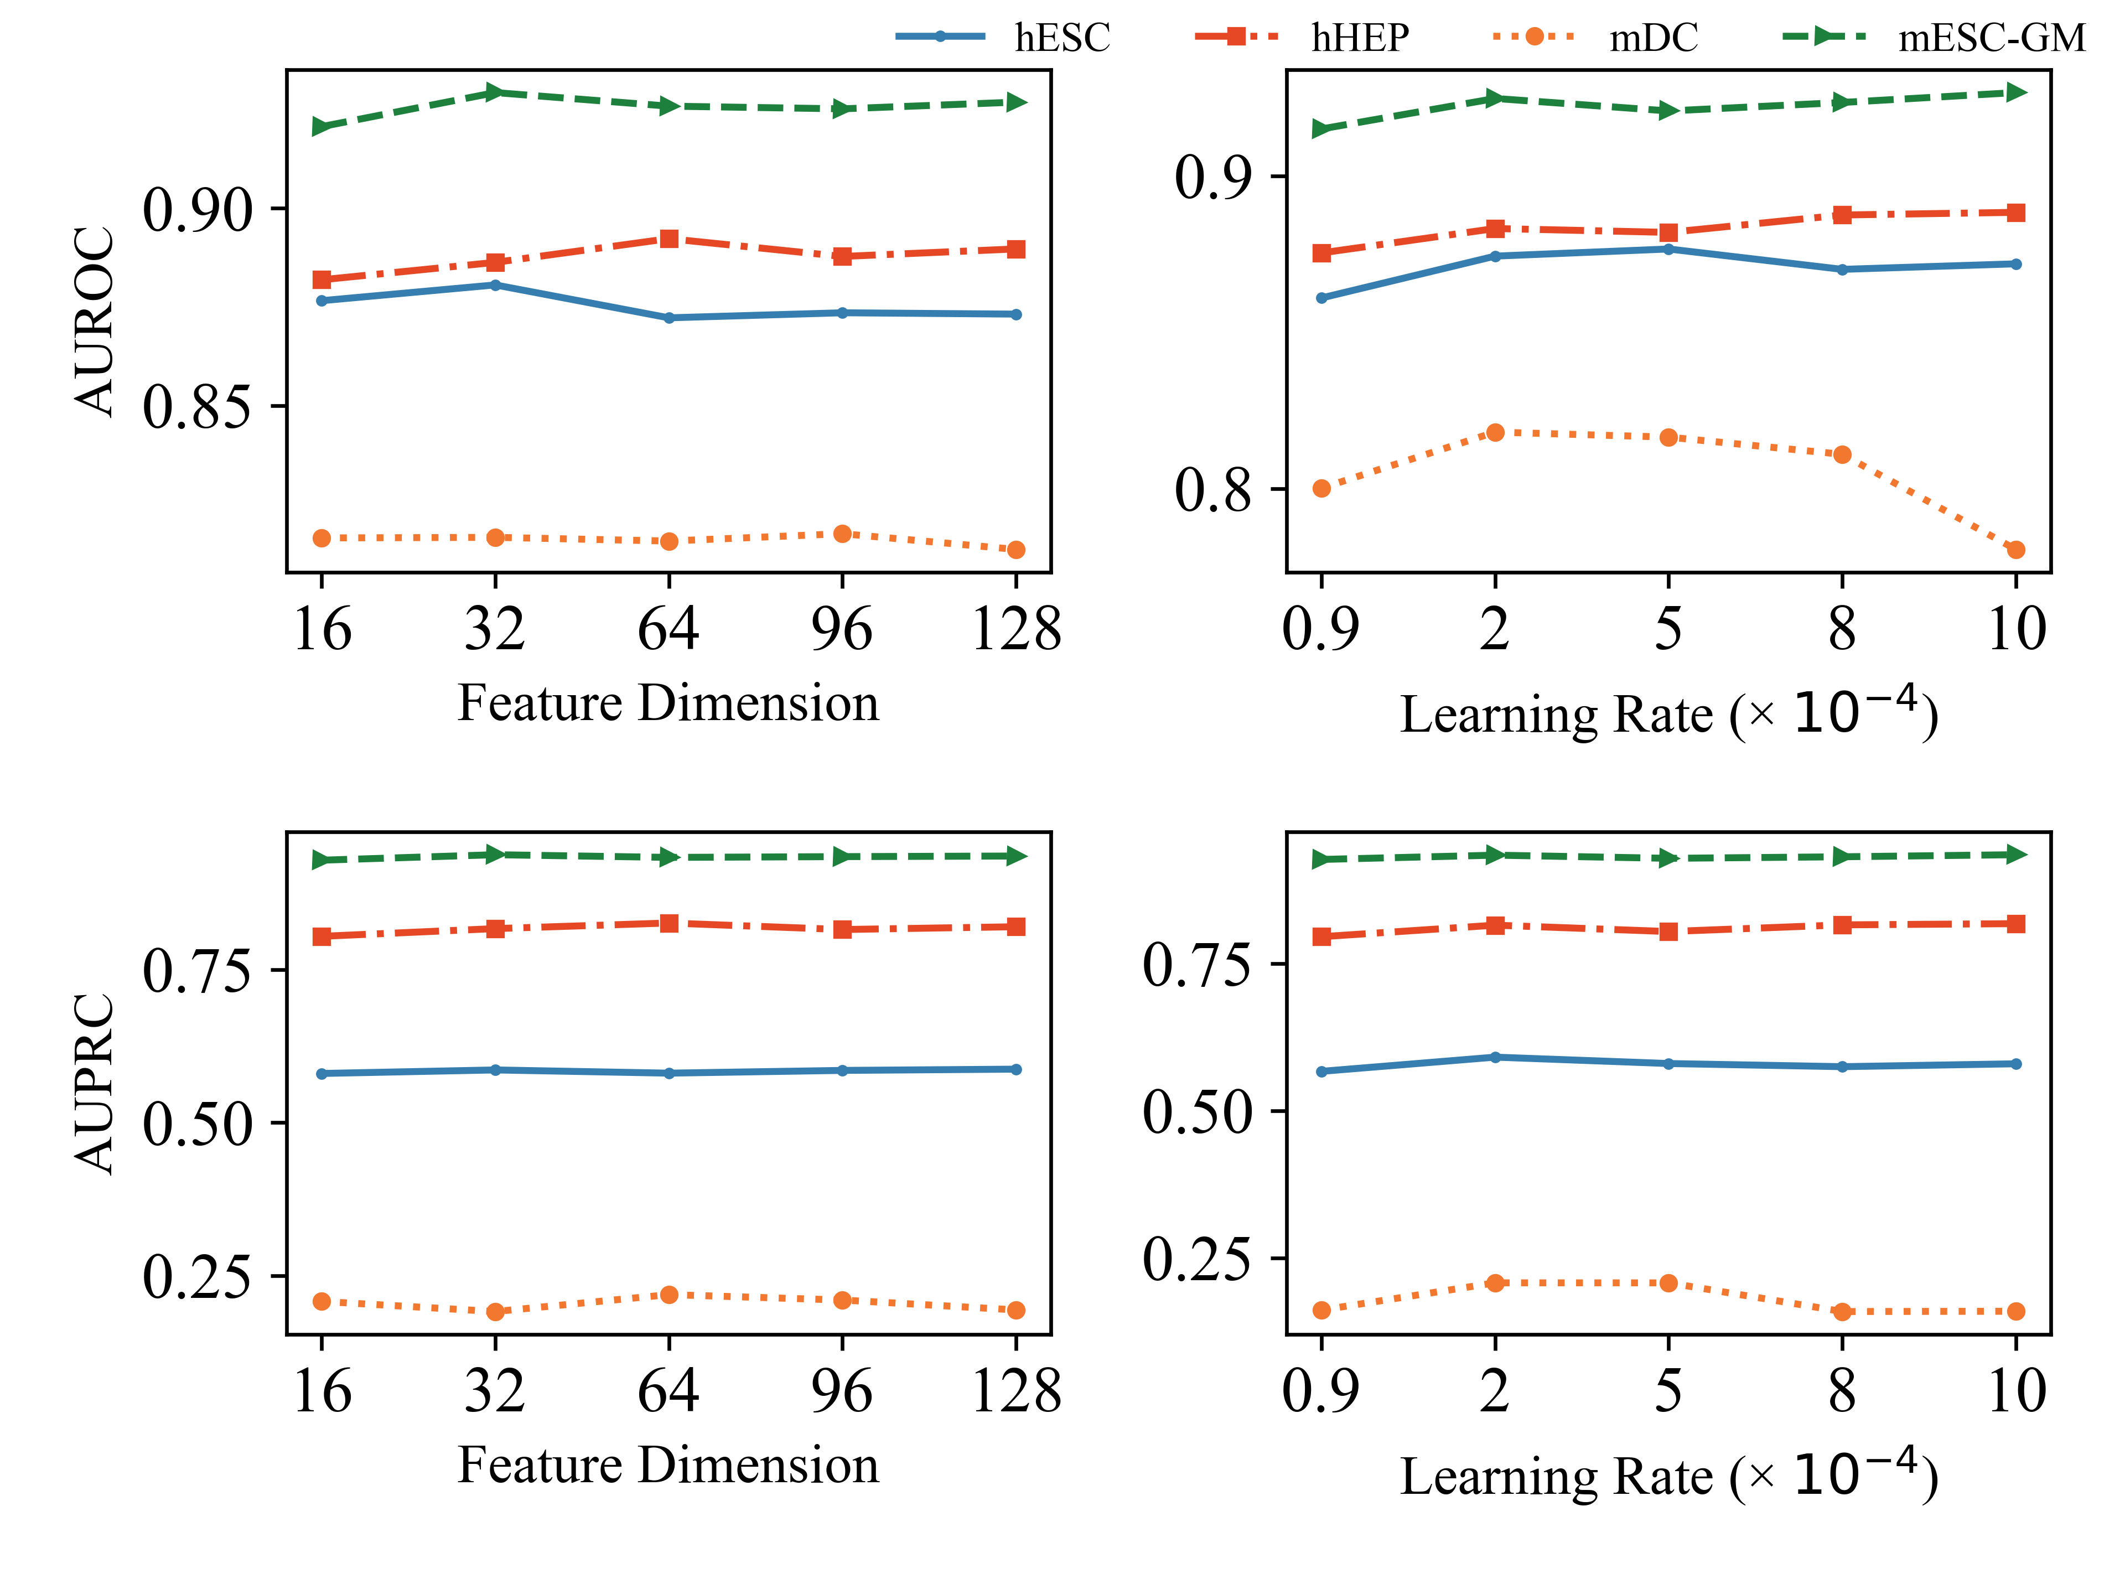

1. Experimental results for output dimensions and learning rates of GATs

## Embedding clustering

To better understand the gene regulatory representations learned by LGATFormer, we utilized t-distributed stochastic neighbor embedding (t-SNE) for visualization in a low-dimensional space. As shown in the first two columns of Fig. 3, we applied t-SNE to both the original paired gene data and the embeddings from the model's penultimate layer, which has a dimensionality of 128. The original data is represented as a two-dimensional matrix of feature vectors corresponding to gene pairs. The embeddings were projected onto a 2D plane, with the left column showing the hESC dataset from STRING networks and the middle column showing the mDC dataset from Non-Specific networks. The embedded representations display significantly improved separability in class distribution compared to the original input, with clear inter-class boundaries and distinct intra-class clustering. This demonstrates that LGATFormer effectively captures and separates regulatory features in the embedding space.

Additionally, we selected two TFs (EP300 and TRP53) along with their corresponding target genes from the hESC dataset in STRING networks to achieve gene-level clustering visualization, as illustrated in the right column of Fig. 3. For EP300, gene pairs involved in regulatory relationships with this TF exhibit a highly concentrated clustering trend, demonstrating a distinct regulatory boundary compared to negative samples. In the case of TRP53, the distribution is more spread out but still shows a clear clustering tendency. These results indicate that LGATFormer effectively integrates latent regulatory features, allowing the model to form more discriminative intra-class clusters and clear inter-class separation in the embedding space. This confirms the model's capability to accurately model GRNs。



1. T-SNE projections and penultimate layer embeddings for all input TF-gene vector pairs (left two columns). T-SNE projection and penultimate layer embedding for a selected TF-gene vector pair (right column)

## The prediction results of TF's target genes demonstrate

Table S2. Top 20 target genes for TFAP2A and OTX2 predicted by LGATFomer on the hESC500 dataset

|  |  |  |  |  |  |
| --- | --- | --- | --- | --- | --- |
| TF | Target | Evidence | TF | Target | Evidence |
| TFAP2A | RBFOX2 | Cistrome DB, Ground-truth | OTX2 | SSB | hTFtarget |
| TFAP2A | ZRANB2 | Ground-truth | OTX2 | CLGN | Unconfirmed |
| TFAP2A | PLAGL1 | Ground-truth | OTX2 | KIF15 | hTFtarget, Ground-truth |
| TFAP2A | POLR2A | Ground-truth | OTX2 | ETV1 | PMID: 28620275, Ground-truth |
| TFAP2A | SMAD5 | Ground-truth | OTX2 | NFYB | hTFtarget |
| TFAP2A | SNAI1 | hTFtarget, Ground-truth  Cistrome DB | OTX2 | ARID3B | hTFtarget |
| TFAP2A | NFATC3 | Ground-truth | OTX2 | WWTR1 | hTFtarget, Cistrome DB |
| TFAP2A | RALB | Ground-truth | OTX2 | GTF2H2 | Unconfirmed |
| TFAP2A | RNF19A | hTFtarget, Ground-truth  Cistrome DB | OTX2 | DNA2 | hTFtarget |
| TFAP2A | ESRRG | Ground-truth | OTX2 | TDP2 | hTFtarget |
| TFAP2A | BARX2 | Cistrome DB | OTX2 | ZRANB2 | Unconfirmed |
| TFAP2A | CDC7 | Ground-truth | OTX2 | HNRNPK | hTFtarget |
| TFAP2A | HMGA1 | PMID: 37586214, Ground-truth | OTX2 | BTBD10 | hTFtarget |
| TFAP2A | TDP2 | Ground-truth | OTX2 | ZNF589 | Ground-truth, Cistrome DB |
| TFAP2A | WDFY1 | hTFtarget, Ground-truth | OTX2 | ODC1 | hTFtarget |
| TFAP2A | ANKRD13C | Ground-truth | OTX2 | MED16 | hTFtarget |
| TFAP2A | PPM1H | hTFtarget, Ground-truth | OTX2 | INSIG2 | hTFtarget |
| TFAP2A | COL4A6 | Ground-truth | OTX2 | SMARCC1 | hTFtarget |
| TFAP2A | NFIA | Cistrome DB, Ground-truth | OTX2 | RGPD2 | Ground-truth |
| TFAP2A | BTBD10 | Unconfirmed | OTX2 | ZNF142 | Ground-truth, Cistrome DB |

Table S3. Top 20 target genes for EGR1 and CREB1predicted by LGATFomer on the hESC500 and hHEP500 datasets

|  |  |  |  |  |  |
| --- | --- | --- | --- | --- | --- |
| TF | Target | Evidence | TF | Target | Evidence |
| EGR1 | NANOG | PMID: 32366479 | CREB1 | POLR1C | hTFtarget, Ground-truth |
| EGR1 | YPEL5 | Cistrome DB | CREB1 | NFYB | hTFtarget, Ground-truth |
| EGR1 | SUPT7L | Cistrome DB, Ground-truth | CREB1 | CUTC | hTFtarget, Ground-truth |
| EGR1 | INSIG2 | Ground-truth | CREB1 | MRPL1 | hTFtarget, Ground-truth |
| EGR1 | ANKRD28 | Ground-truth | CREB1 | GTF2H2 | Ground-truth |
| EGR1 | FOXP1 | Ground-truth | CREB1 | NUP35 | hTFtarget, Ground-truth |
| EGR1 | SSB | Cistrome DB, Ground-truth | CREB1 | ICE2 | hTFtarget, Ground-truth |
| EGR1 | XRN1 | Ground-truth | CREB1 | RNPS1 | hTFtarget, Ground-truth |
| EGR1 | BCLAF1 | Ground-truth | CREB1 | NUP93 | hTFtarget, Ground-truth |
| EGR1 | CSDE1 | Ground-truth | CREB1 | WDR12 | hTFtarget, Ground-truth |
| EGR1 | WDR12 | Ground-truth | CREB1 | MTF2 | PMID:29298996, Ground-truth  hTFtarget, |
| EGR1 | ESRP1 | Ground-truth | CREB1 | BRIX1 | hTFtarget, Ground-truth |
| EGR1 | SEMA3A | Ground-truth | CREB1 | KLHL7 | hTFtarget, Ground-truth |
| EGR1 | SRSF10 | PMID: 34616729, Ground-truth | CREB1 | PEMT | hTFtarget, Ground-truth |
| EGR1 | TIPIN | hTFtarget, Cistrome DB  Ground-truth | CREB1 | MIS18BP1 | hTFtarget, Ground-truth |
| EGR1 | FOXN3 | hTFtarget, Cistrome DB  Ground-truth | CREB1 | TCERG1 | hTFtarget, Ground-truth |
| EGR1 | SFPQ | Ground-truth | CREB1 | TPX2 | hTFtarget, Ground-truth |
| EGR1 | BTBD10 | Ground-truth | CREB1 | MCM8 | hTFtarget, Ground-truth |
| EGR1 | OTX2 | Ground-truth | CREB1 | ZNF33A | hTFtarget, Ground-truth |
| EGR1 | SLC6A15 | Cistrome DB, Ground-truth | CREB1 | HNRNPR | hTFtarget, Ground-truth |

## Model parameters

|  |  |
| --- | --- |
| Parameter | Value |
| Number of GAT layers | 3 |
| Number of attention heads per GAT layer | 2 |
| Output dimension of each GAT layer | 32 |
| Number of attention heads in the Transformer encoder | 4 |